**0For Immediate Release**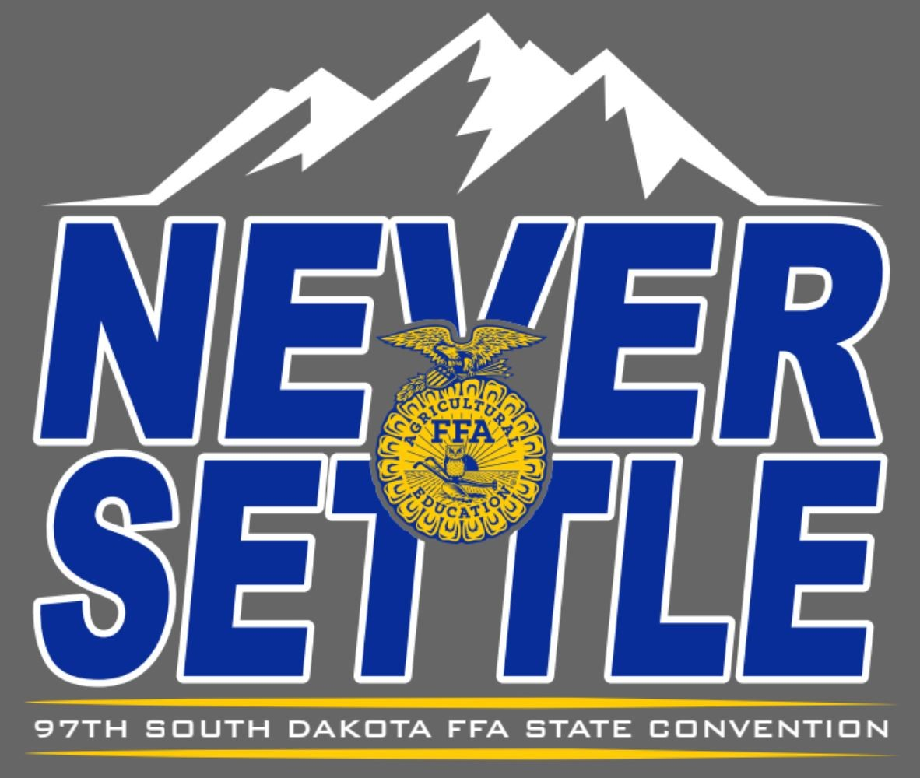

Contact: Caroline Hansen

SD FFA Leadership & Program Manager

[Caroline.Hansen@sdaged.org](mailto:Caroline.Hansen@sdaged.org)

**Photos of STAR finalists available to download at:** [**https://drive.google.com/drive/folders/1p8_W46-v7wKXxtQxzx75sJV_5j3K8FrV**](https://drive.google.com/drive/folders/1p8_W46-v7wKXxtQxzx75sJV_5j3K8FrV)

**South Dakota State FFA Stars Recognized**

(BROOKINGS, S.D.) – The State FFA Degree, the highest degree conferred by the South Dakota FFA, was presented to 324 agricultural education students at the 2025 South Dakota FFA Convention. Certain students rise to the top as star finalists. These individuals spend countless hours working on their projects and enhancing their potential for future jobs by gaining hands-on experience and developing technical skills. After a review of the students' supervised agricultural experience program and records, four finalists were selected as the best of the best in each category prior to state convention. The finalists interviewed in front of a panel and the most outstanding were selected to be the State Star Farmer, Star in Agribusiness, Star in Placement and Star in Agri-Science. Each State Star will receive a $500 cash award and the finalists each receive $150. Congratulations to the SD FFA Stars!

The results are as follows:

**State Star Farmer – Colton Stiefvater, McCook Central** sponsored by Farm Credit Services of America. His advisor is Mr. Terry Rieckman

**State Star in Ag Placements - Dylan McGregor, McCook Central** sponsored by The Dan and Karen Streff family. His advisor is Mr. Terry Rieckman

**State Star in Agriscience - Lauren Roling, McCook Central** sponsored by Glacial Lakes Energy. Her advisor is Mr. Terry Rieckman

**State Star in Agribusiness - Skyler Plucker, Lennox-Sundstrom** sponsored by Farm Credit Services, Jarod Weber, sponsor, pictured. His advisor is Mrs. Kasey Trocke

Finalists and winners in all 4 areas are as follows (photos):

**Star Farmer finalists** – Sponsor Farm Credit Services of America; Ireland McAreavey, Tri-Valley; Josie Nold, Brookings; Jason Zeeb, Bridgewater-Emery

**Star in Ag Placement finalists** – sponsor, The Dan and Karen Streff family; Mason Jacobson, Howard; Ridge Roduner, Wessington Springs; Brody Stenger, Sioux Falls CTE;

**Star in Agriscience finalists** – sponsored by Glacial Lakes Energy: Joseph Grady, McCook Central; Colten Stiefvater, McCook Central; Karlie Stiefvater, McCook Central

**Star in Agribusiness finalists** – sponsor Jarod Weber, Farm Credit Services: Isaac Boden, Beresford; Abbie Chase, McCook Central; Talen Hazel, Beresford

District Star Greenhands are sophomores who were recognized for an outstanding start to their Supervised Agriculture Experience Project as being top in each of their FFA districts. These awards were sponsored by Central Farmers Cooperative.

**District Star Greenhands are:** District winners are: District One: Keaton Zubke, **Florence FFA**; District Two: Korbin Shumaker, **Howard FFA**; District Three: Clayton Pankratz, **Parker FFA**; District Four: Tucker Peterson; **McCook Central FFA** District Five: Ray Sanders, **Hot Springs FFA;** District Six: Rylee Knock, **Hitchcock-Tulare FFA**; District Seven: Kendall McAreavey, **Tri Valley FFA**; District Eight: Ayla Bauer, **Lemmon FFA**.

-###-